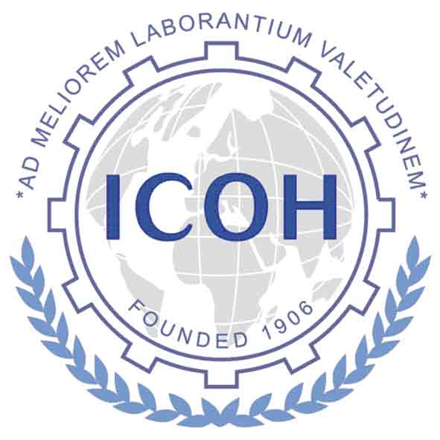
ICOH 2022-2024 TRIENNIUM

REPORT OF SCIENTIFIC COMMITTEE BUSINESS MEETING

Please send the report of the business meeting of the Scientific Committee held during the ICOH2022 Melbourne – Rome global digital Congress, 6-10 February 2022 to:

Vice President: Claudina Nogueira claudinanogueira@hotmail.com
cmcanogueira@gmail.com

You may provide the Minutes of the Meeting as they were taken, or you may fill in the relevant sections of the form.

This form can also be used for other business meetings held during the ICOH 2022-2024 Triennium. Please send the form within a month after the business meeting.

Name of Scientific Committee (SC):

Name of Chair:
Email address:

Name of Secretary:
Email address:

Date of Business Meeting:

Location: (Country, City, Venue)

Participants: (Please add list here)

Discussion Points: Please provide information on the following Discussion Points if discussed at the meeting and not presented in the minutes you have attached.

- List scientific conferences, seminars, workshops held PRIOR to this business meeting. Provide event name, date, location, number of attendees, co-sponsors.

- List scientific conferences, seminars, workshops PLANNED to occur AFTER this business meeting. Provide event name, date, location, co-sponsors.

- List scientific products completed or underway. Provide title, authors, type of document, intended audience, collaborators, publication vehicle.

- Communications: List those used by the SC. Provide URL if electronic.

- Identify collaborations with other SCs and non-ICOH organizations.

- Value and Impact of the SC: Please provide your assessment of the success and impact of the SC on global occupational health. Would you recommend actions to increase the impact?

- Other Key Points of Discussion:

Submitted by:

Date:

